**MIND TRAINER**

**INTRODUCTION**

“Mind Trainer for specially enabled children” is an educational game for the children with special needs to learn simple English and basic maths as they play games.

Nowadays, the attention to people with special needs, especially to those with communication disabilities, is an area in continuous expansion in our society. Hence it is very important to develop technological solutions for the rehabilitation and integration of people with communication disabilities, independently from their problems.

Games can be powerful tools that significantly boost personal development and learning achievement. The games can be specially designed to develop important abilities or teach specific skills or concepts. In Mind Trainer children are engaged in a fun and motivating environment.

Specially enabled children are unique and have their own distinct needs and learning difficulties. Children with special needs listen more attentively and remember things better when they are given an attractive and convenient environment. Mind Trainer is an effective educational tool that provides such an environment that can help children with special needs reach their full potential and experience success in basic English and simple Maths.

Mind Trainer enables children to learn at their own pace and speed in a positive, confidence-building environment, which is especially important in meeting the learning requirements of children with special needs. The child can practice their skills before they receive their puzzles. This way it can be made sure the child has mastered key concepts before moving on to the puzzles.

In Mind Trainer the child is taken step by step in the learning process. First they train themselves and then go through a series of puzzles to test what they have learnt. They are given scores based on their performance and provide a means to evaluate themselves. Thus they can train more in which they get less scores.

**USERS OF THE SYSTEM**

The users of the system are:

* Differently abled children who cannot use the keyboard like normal people.
* Admin who creates player login, maintain database for puzzles and scores.
* Kids at elementary level to train themselves in basic English and maths.
* Any person who would like to test their speed and knowledge in English and maths.

Scanning mode is used by the differently abled children and others can use the keyboard.

Scanning mode:

Scanning mode is used in Mind Trainer for the differently abled children to give input. They cannot make use of the keyboard or other input devices. They can make use of a switch which is equivalent to the left button click of the mouse. So every input in Mind Trainer is converted into the left button click of the mouse.

**Overall view of Mind Trainer**

The Mind Trainer is an educational game to make the differently abled children learn simple maths and basic English.

The main aim of the project is to provide a complete environment for the differently abled children to learn well.

There are two users for the system

* Admin
* Player

The facilities provided for the Admin are :

* Creation of new login for the players and maintaining a record of their performance.
* Creation and maintenance of databases for the generation of English puzzles.

The various operations that can be done by the player are:

* Teach themselves simple maths and basic English.
* Train themselves by answering the puzzles generated depending on what they have learnt.
* After sufficient training face play alone mode and record performance.
* Face puzzles in head to head mode to enable group performance.

**ADMIN LOGIN**

The task of the admin in Mind trainer is to maintain login of players and databases for English puzzle generation.

The admin creates separate login id for each player. The player uses this login id to face puzzle in play alone mode.

The admin creates and maintains tables in database for English puzzles.

The elements in English puzzles are:

* Meanings
* Opposites
* Contractions
* Homophones
* Singular-plural
* Vocabulary

In each table the operations that can be done by the admin are add, update and delete.

**Sample screen shots for Admin Login**

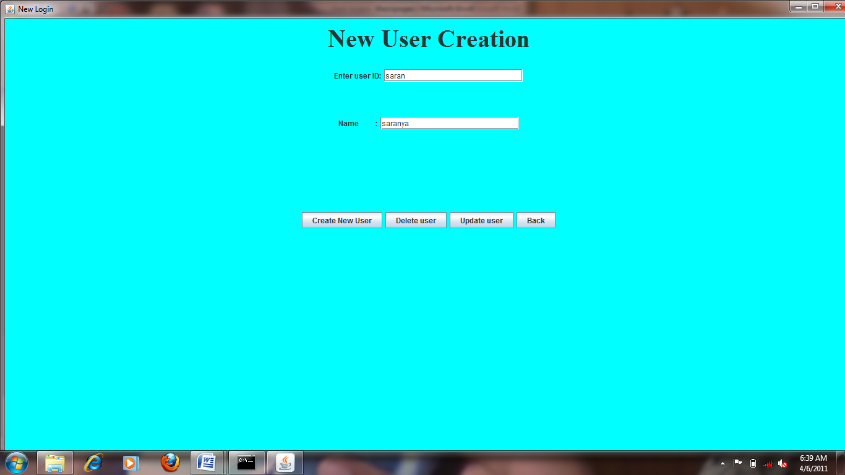

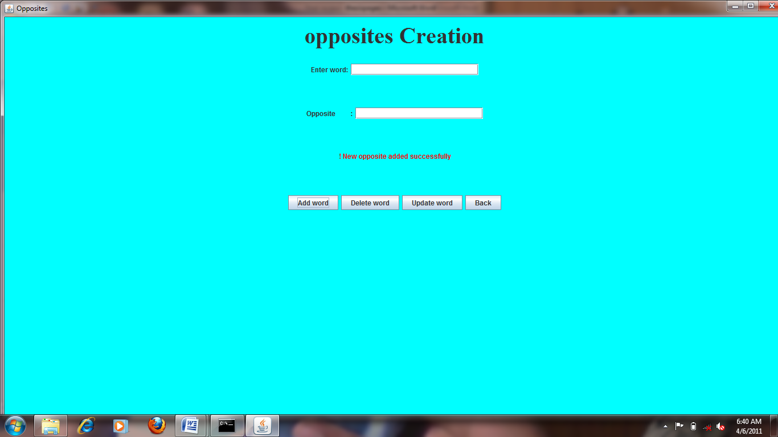

**screen shots for admin to make entries**

This figure demonstrates the screen for admin to create new login for the player and for adding entries in opposites list. Admin has to make the necessary entries and has to click the desired operation.

**PLAYER LOGIN**

The player can make the desired initial settings and choose any one of the desired puzzle. The types of puzzle are :

* Maths puzzle
* English puzzle

The setting that can be can be done by the player are:

* Speed
* Size

Screen shot for making initial settings

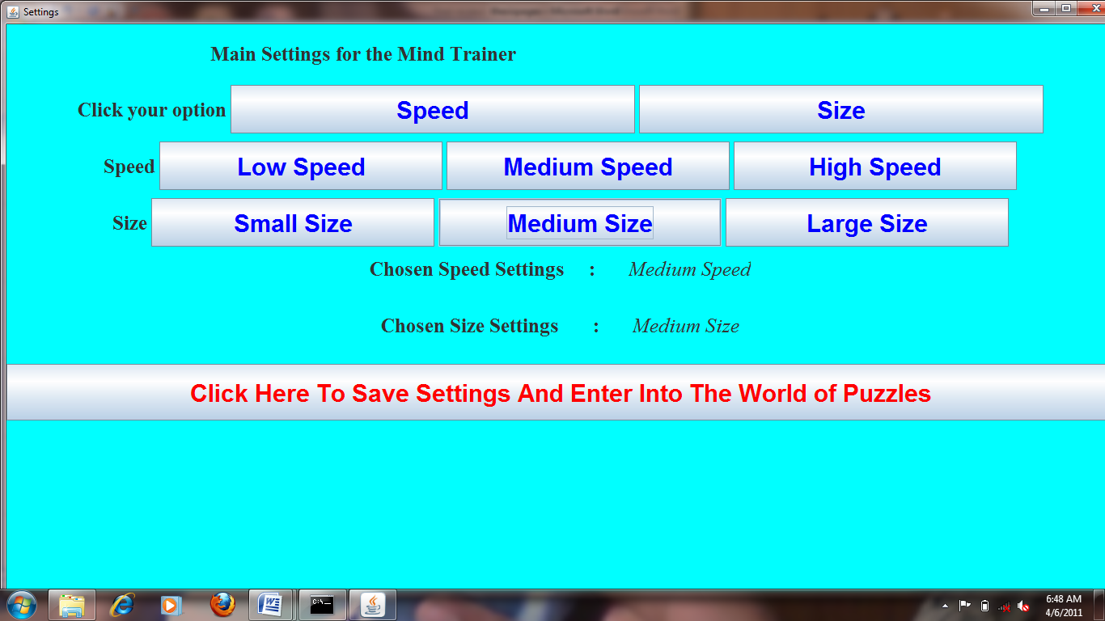

**MATHS PUZZLE**

The various option for the player in maths puzzle are:

* Teach yourself

In the teach yourself mode the player, the player can teach himself the basic operation in maths such as addition, subtraction, multiplication, and division. The child can learn the basic operation for any two numbers. The number can be positive or negative. Thus the child learn maths well using this.

* Self train

In the self train mode the child faces puzzles in addition, subtraction, multiplication and division in various stages. The puzzles are generated randomly and the corresponding answers are generated in the answer pad with additional numbers. The task of the child is to give answer using the scanning mode. In the scanning mode, each answer gets focus in specific time intervals. The child has to answer when the correct answer ges focus. If the child answers all the puzzles correctly then it wins the mission.

If the child fails to solve any of the puzzle then the igloos are destroyed.

* Play alone

In the play alone mode, the player has to face puzzles in various stages.If the player solves all the puzzles in all the stages, then the player has mastered everything. If the player loses in any of the stage, then the player has to train more in that level. The level reached by each player is saved to indicate performance.

* Play head to head

In the play head to head mode, two player can choose a puzzle type to face. Then each player faces the puzzles one by one. Scores are generated for each player based on their performance. The player with the highest score is declared to be the winner.

**NUMBER PUZZLE**

Screen Shot for various operations in number puzzle

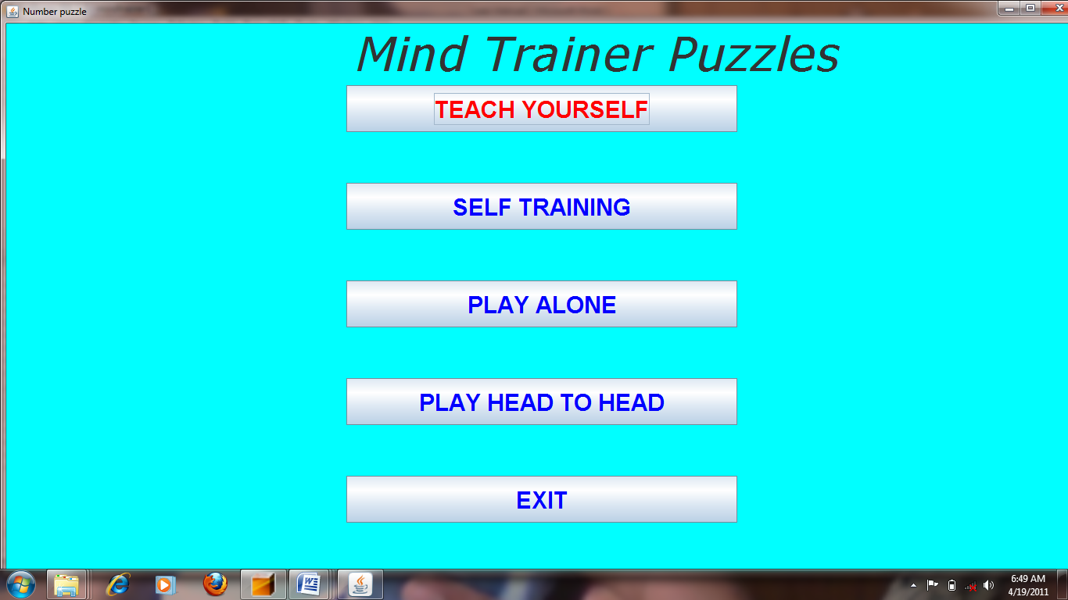

There are various options in number puzzle which are teach yourself, self train, Play alone and head to head. The player can choose any one of the mode.

**NUMBER PUZZLE – TEACH YOURSELF MODE**

Screen shot for teach yourself mode

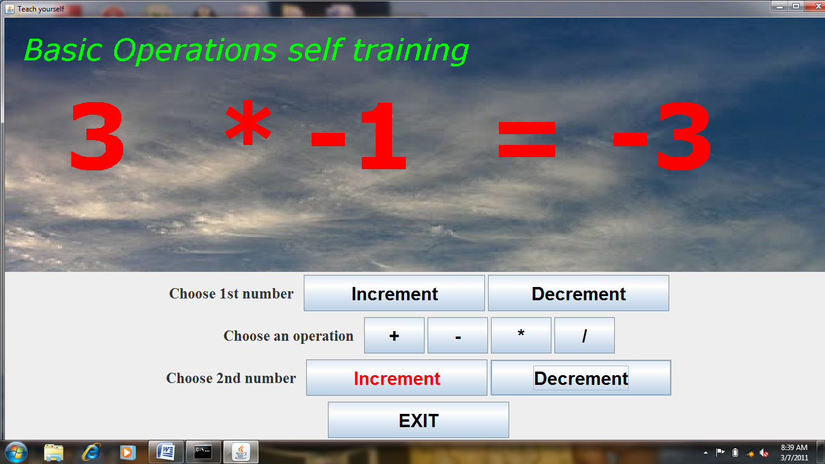

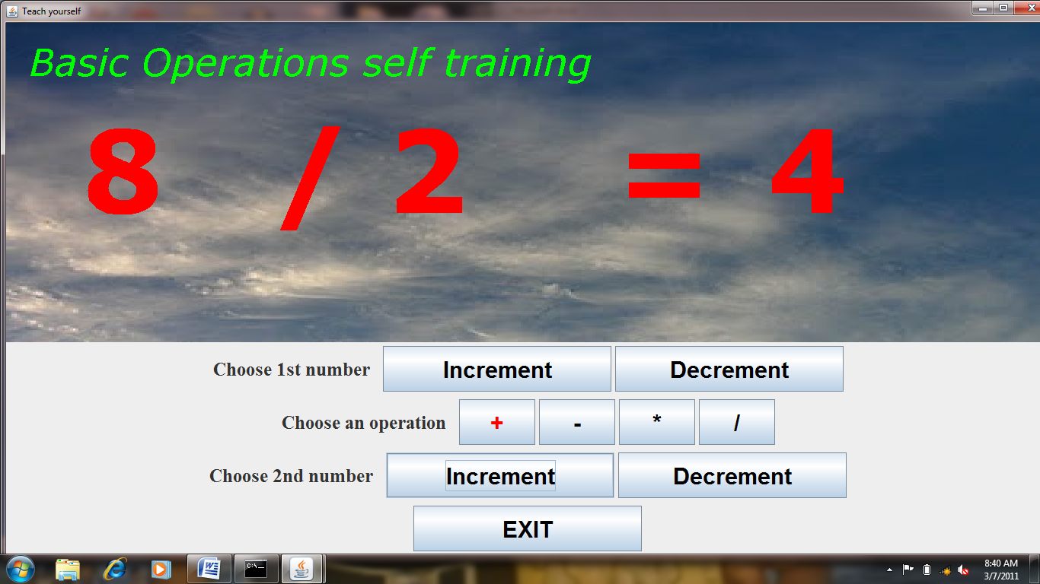

In teach yourself mode the player can choose any two by the way of incrementing and decrementing. Any one of the basic operation to be done on the two numbers can be chosen next. The result of the operation on the two numbers will be shown. In this way the child can learn.

**NUMBER PUZZLE – SELF TRAIN MODE**

In the self train mode the child faces puzzles in addition, subtraction, multiplication and division in various stages.

The types in basic maths are

* Addition
* Subtraction
* Multiplication
* Division

The various sub stages in addition are:

* Addition : Single digit number
* Addition : sums to 30
* Addition : sums to 50
* Addition : sums to 100
* Addition : Find missing numbers
* Addition : positive and negative
* Addition : negative and negative

The various sub stages in subtraction are:

* Subtraction : Single digit number
* Subtraction : 0 to 30
* Subtraction : 0 to 50
* Subtraction : 0 to 100
* Subtraction : Find missing numbers
* Subtraction : positive and negative
* Subtraction : negative and negative

The various sub stages in multiplication are:

* Multiplication : 1 to 3
* Multiplication : 1 to 5
* Multiplication : 1 to 7
* Multiplication : 1 to 9
* Multiplication : Find missing numbers

The various sub stages in division are:

* Division : 1 to 3
* Division : 1 to 5
* Division : 1 to 7
* Division : 1 to 9
* Division : Find missing numbers

In this way the child can self train itself until it is confident that it has mastered all the stages in all the types.

Screen shot for various stages in self train mode

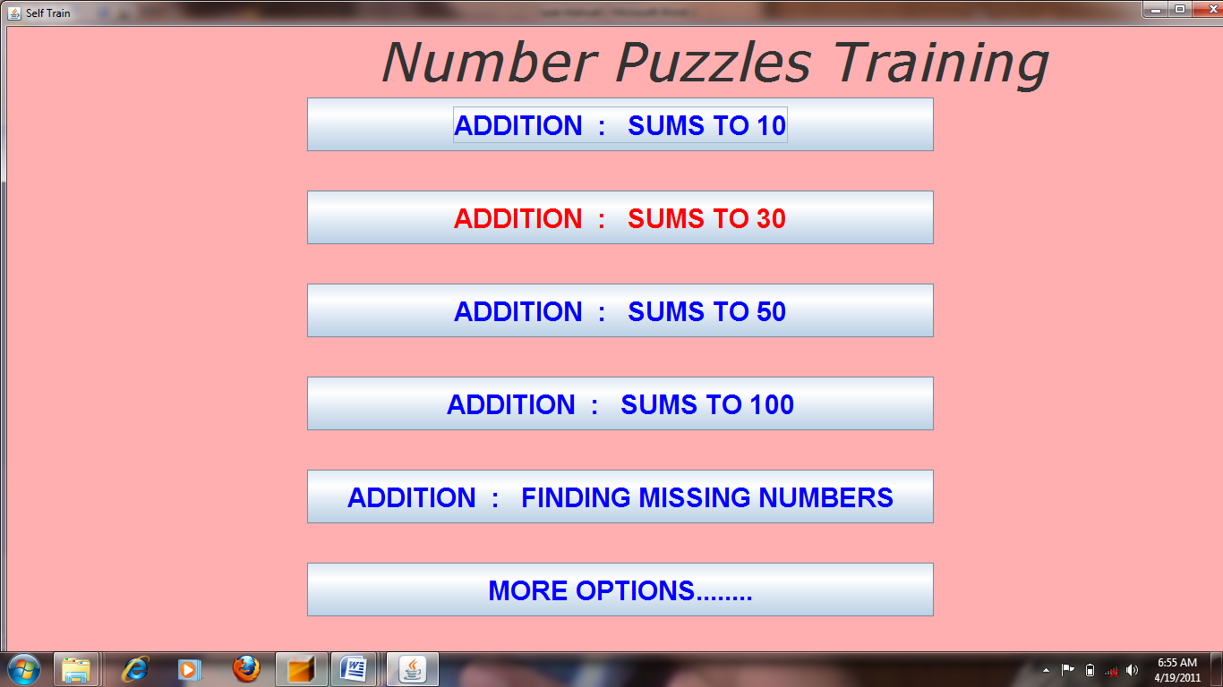

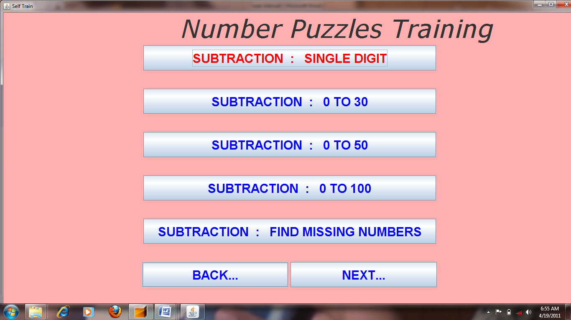

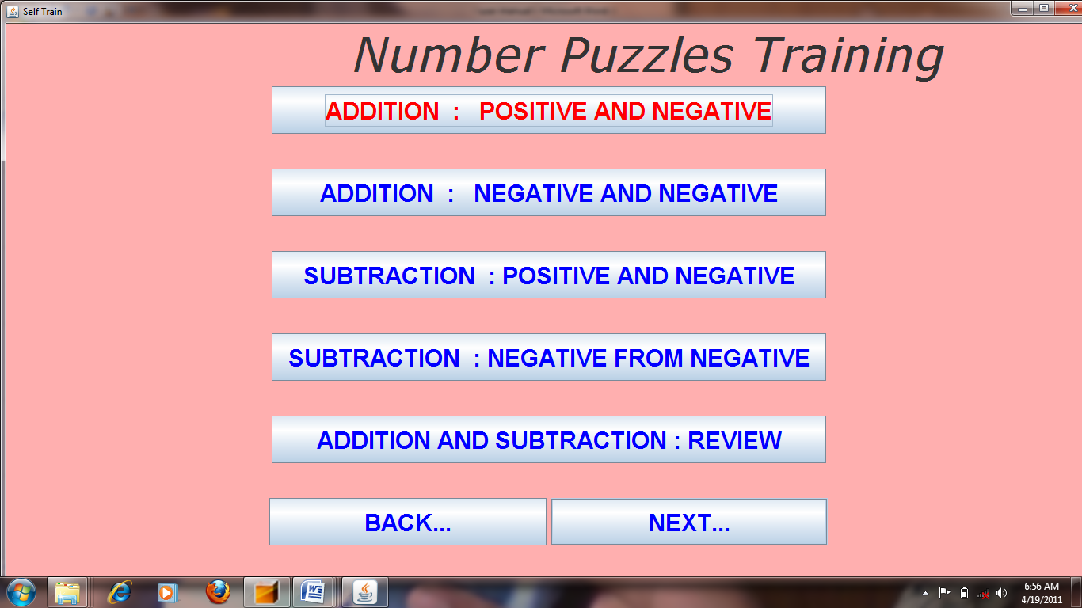

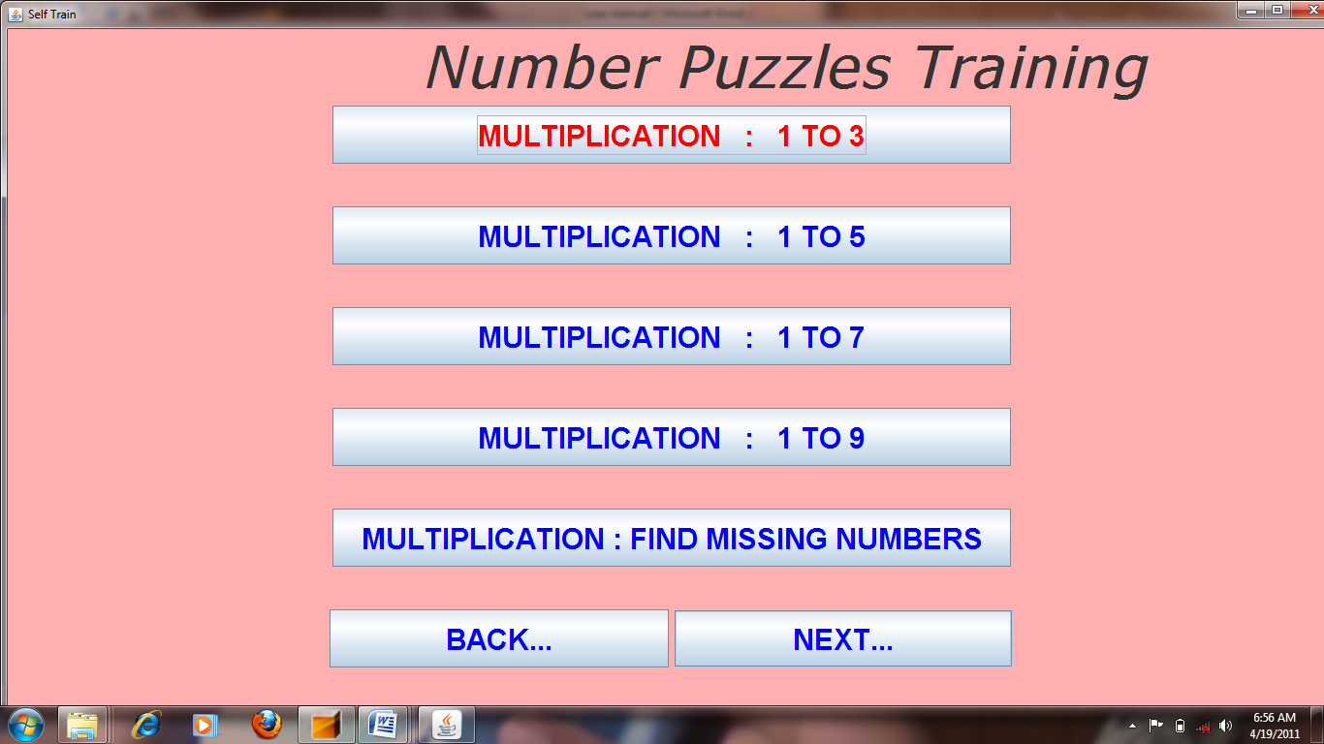

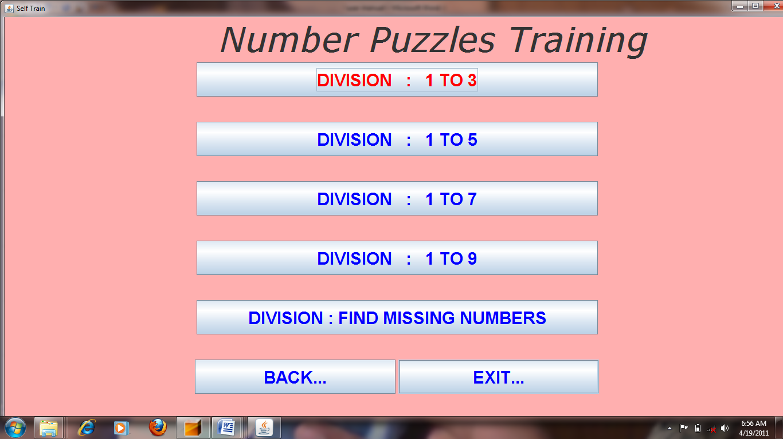

In self train mode the player can learn addition, subtraction, multiplication and division by the way of puzzles generated for them. This screen shot lists some of the stages in addition and subtraction.

**Number puzzles – Puzzles generation**

The player can choose any of the stage and puzzles are generated accordingly.

Screen shots for puzzle generation - Addition

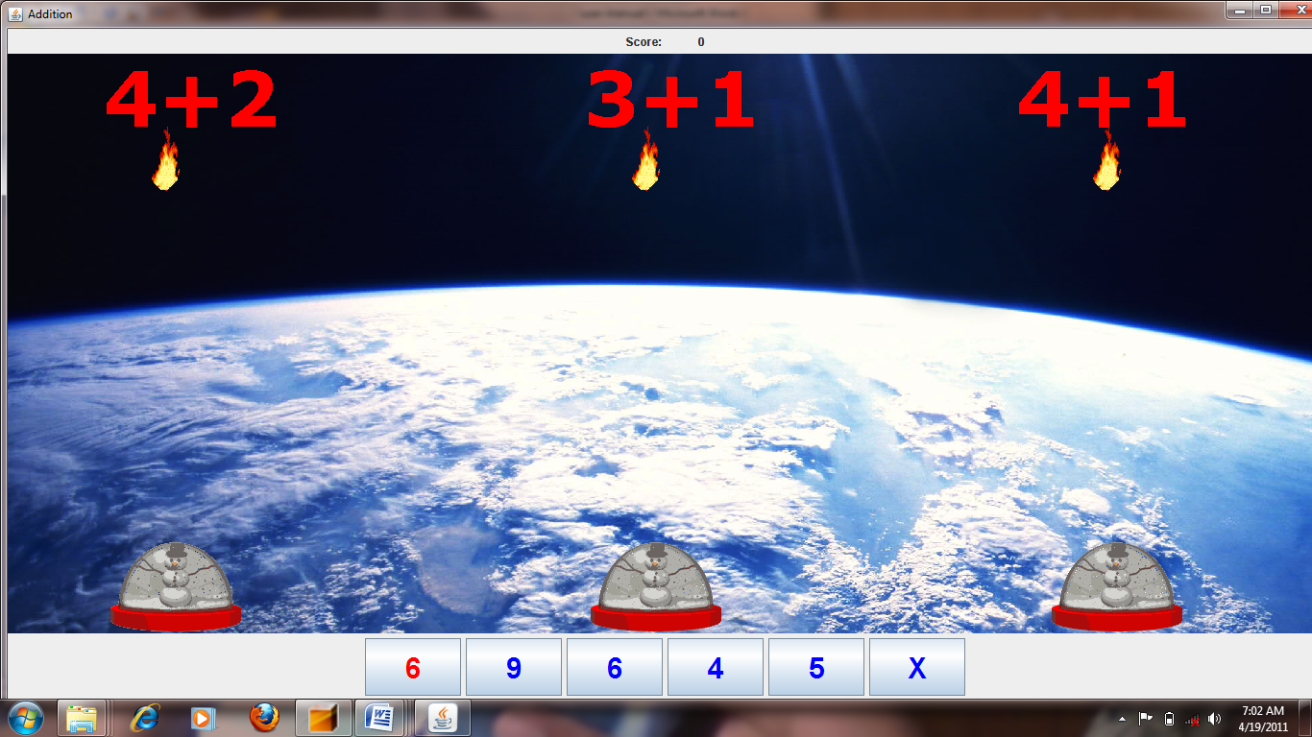

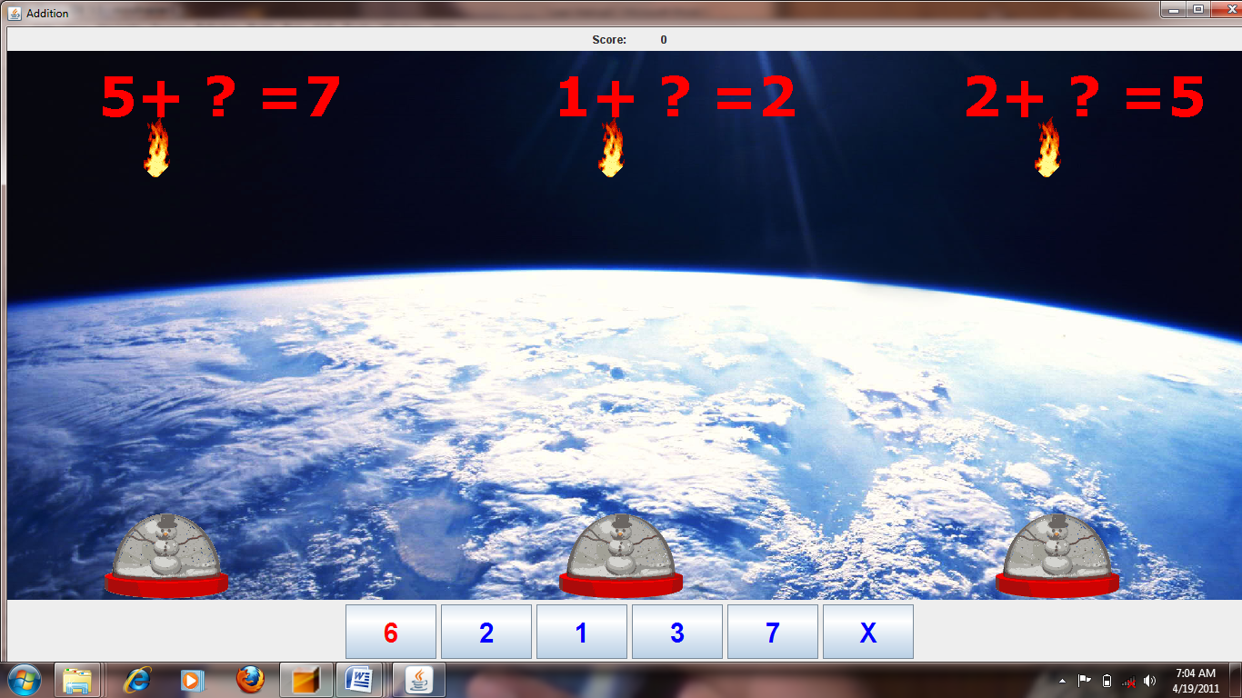

The player has to click the correct answer for the puzzle generated before they reach the igloo.

Screen shots for puzzle generation - Subtraction

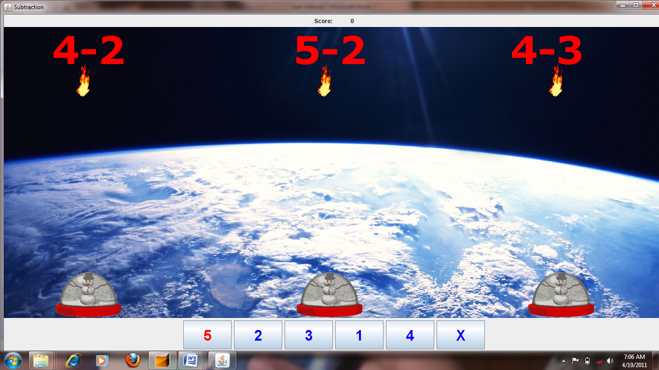

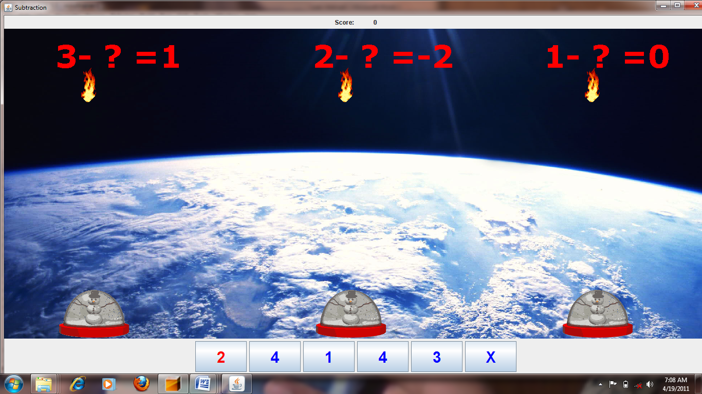

Screen shots for puzzle generation – Negative numbers

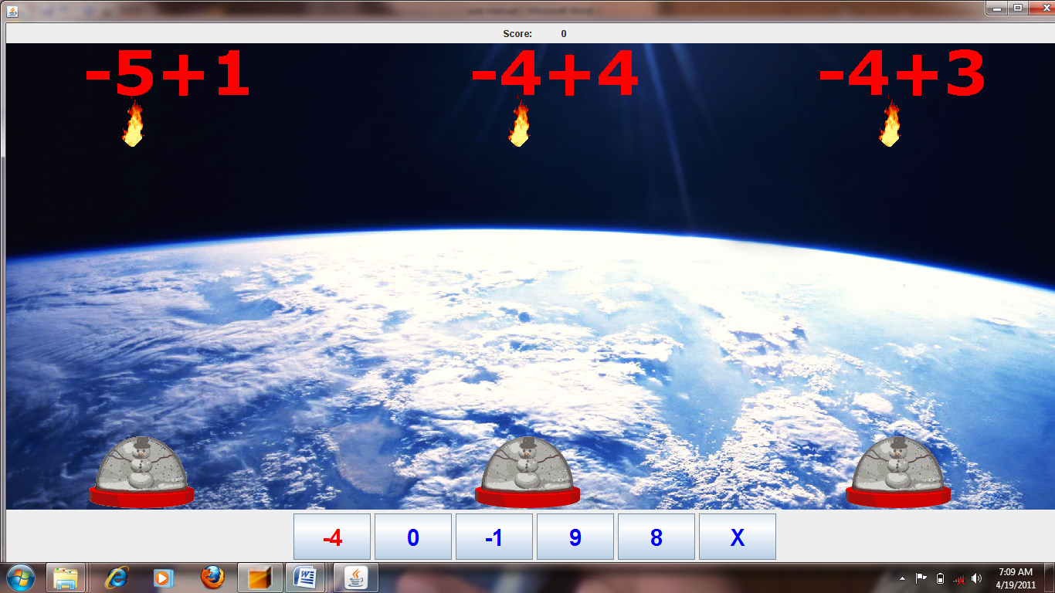

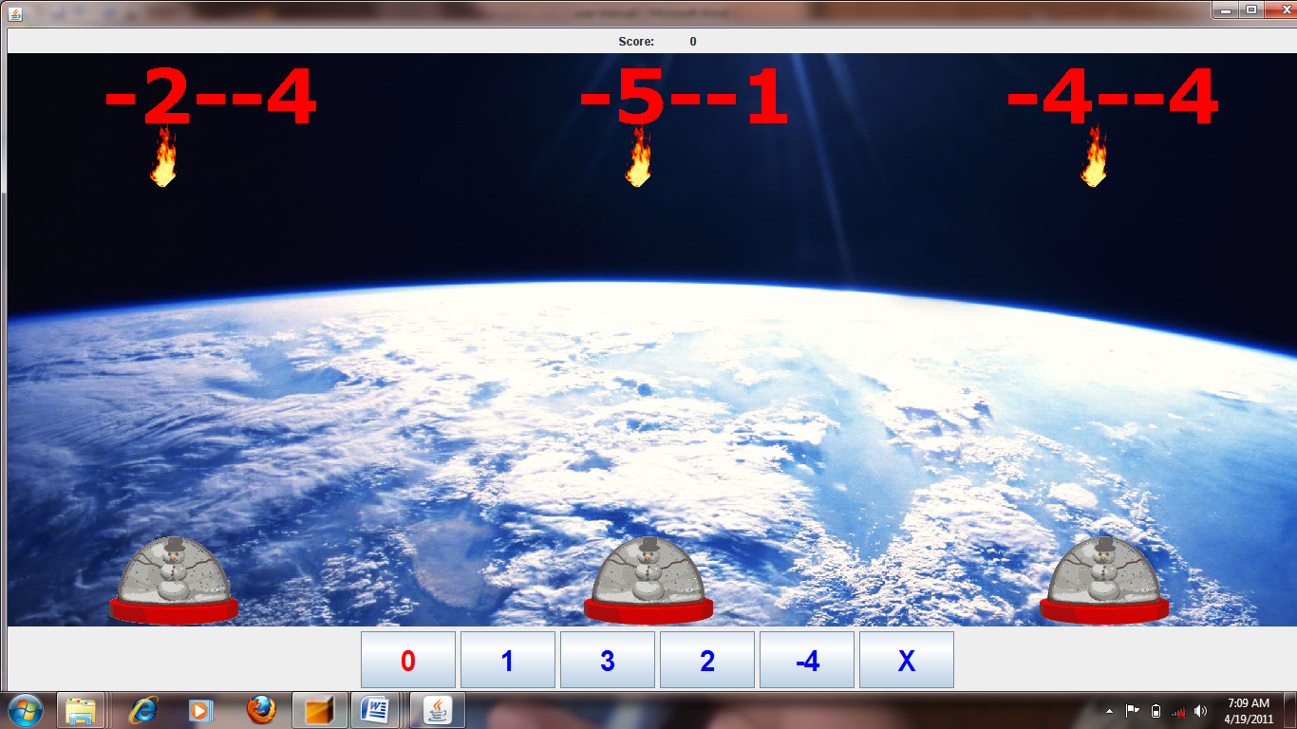

Screen shots for winning and losing

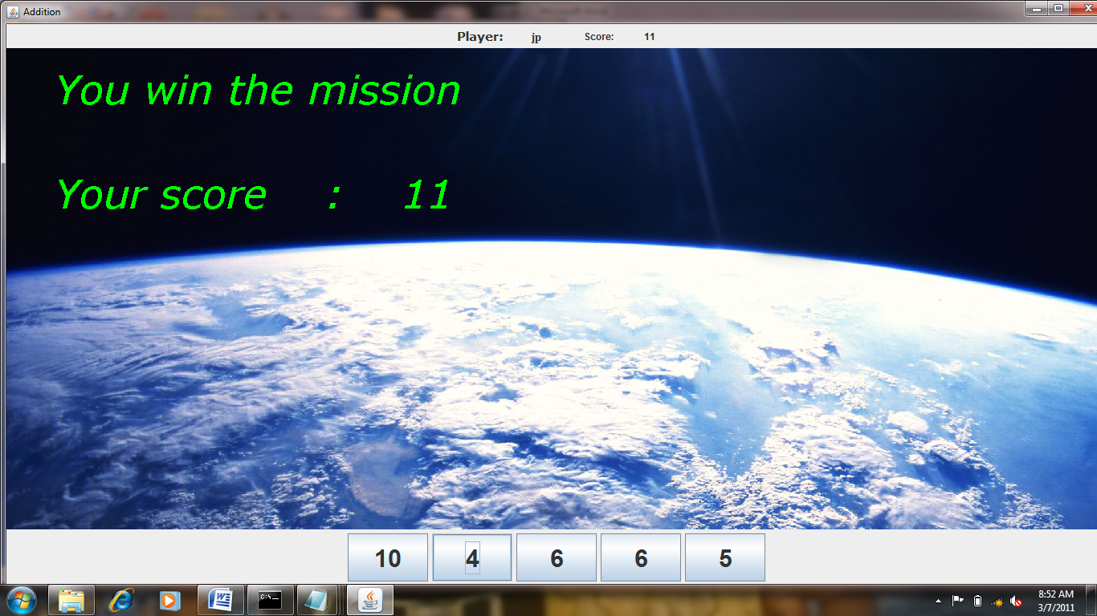

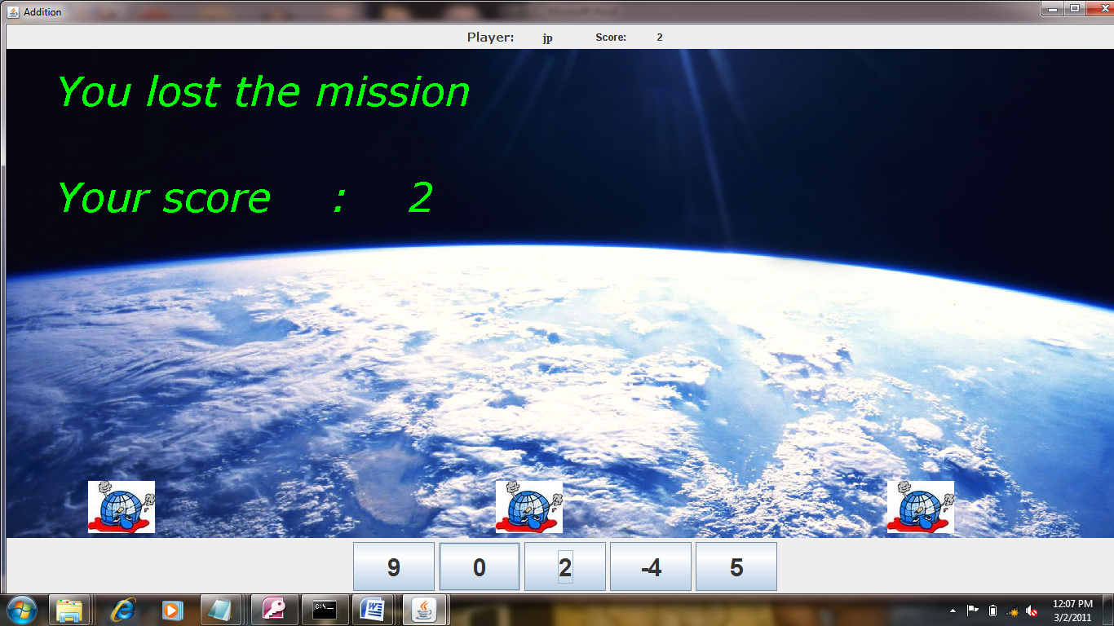

This figure demonstrates the winning and losing stage of the player with the score generated by them. If the player solves all the puzzles within time then he wins else he loses.

**NUMBER PUZZLE – HEAD TO HEAD MODE**

**Screen shots for head to head mode**

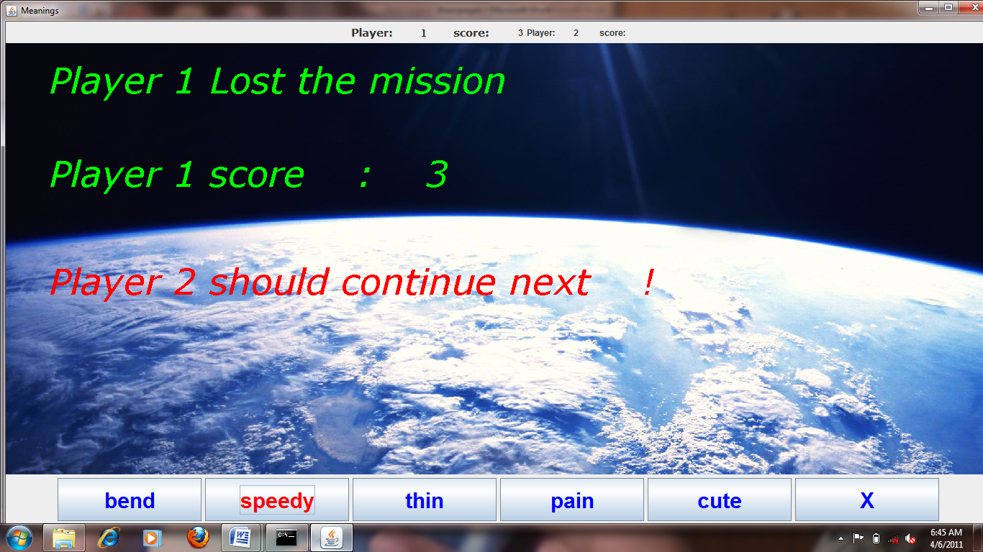

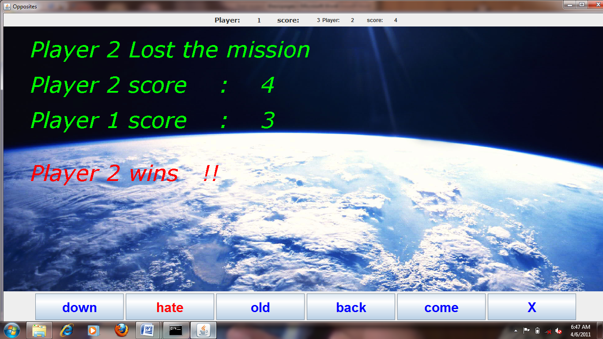

**ENGLISH PUZZLE**

The various option for the player in english puzzle are:

* Teach yourself

In the teach yourself mode the player, the player can teach himself the basic operation in english such as meanings, opposites, homophones, contractions, singular-plural, tenses and vocabulary. Thus the child learn english well using this.

* Self train

In the self train mode the child faces puzzles in meanings, opposites, homophones, contractions, singular-plural, tenses and vocabulary. The child has to solve those puzzles by answering correctly using scanning mode within specific time. If the child is able to solve all the puzzles correctly, then the child wins the mission and has learnt well. If the child is not able to solve all the puzzles correctly, then the child loses the mission and has to learn well.

* Play head to head

In the play head to head mode, two player can choose a puzzle type to face. Then each player faces the puzzles one by one. Scores are generated for each player based on their performance. The player with the highest score is declared to be the winner.

**SCREEN SHOT FOR VARIOUS OPTIONS UNDER ENGLISH PUZZLE – TEACH YOURSELF MODE**

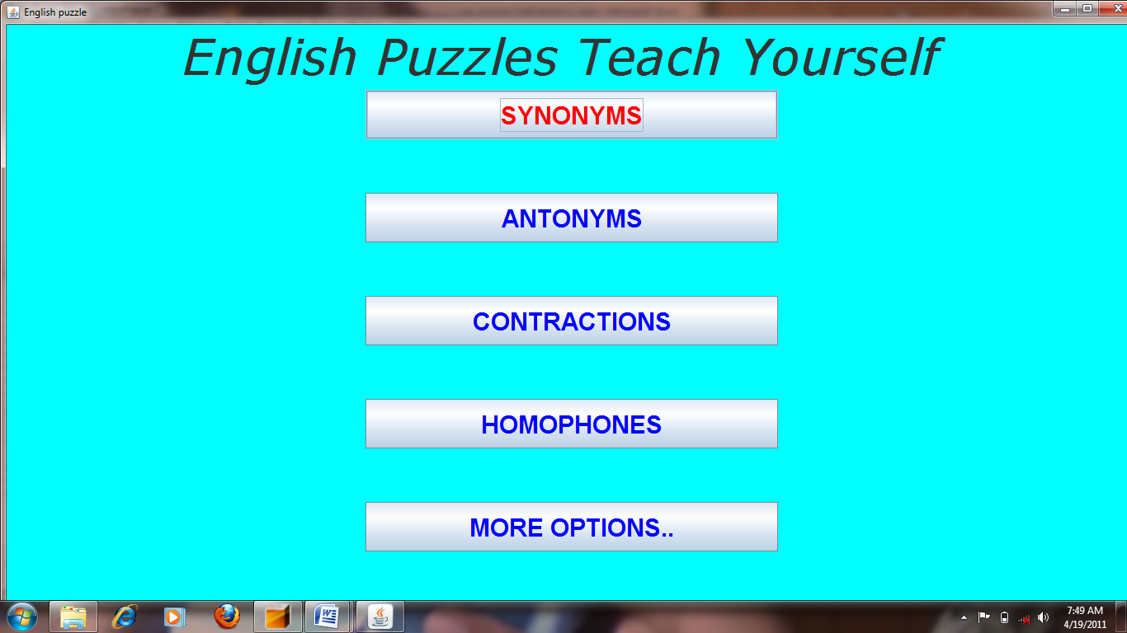

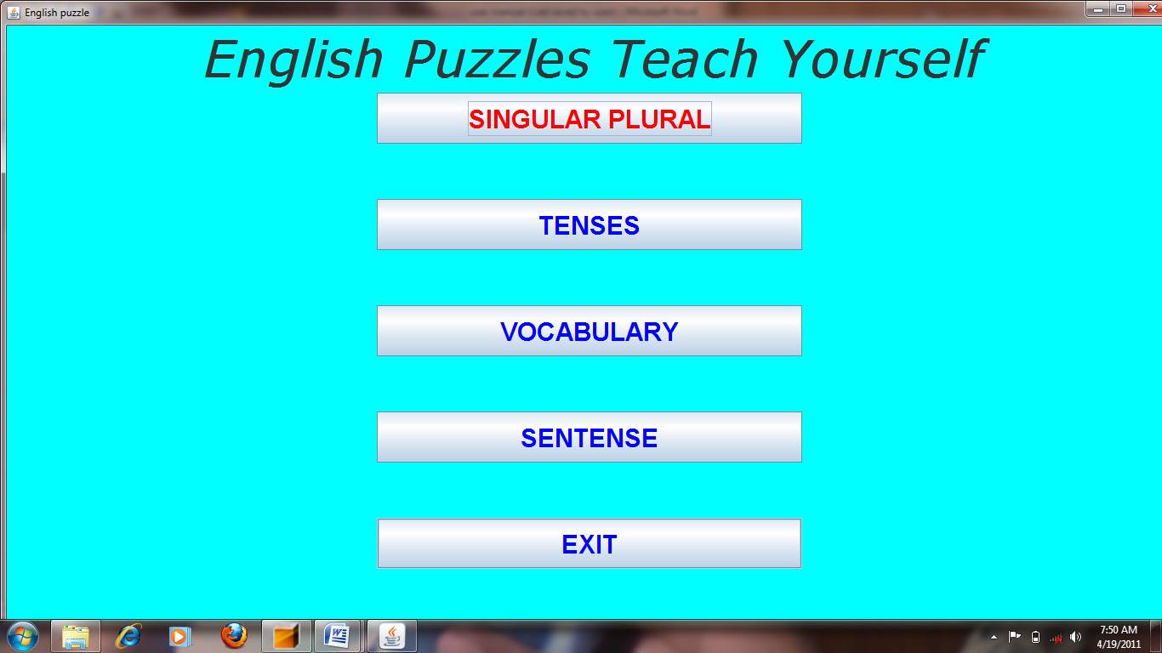

**Screen shot for teach yourself mode in English**

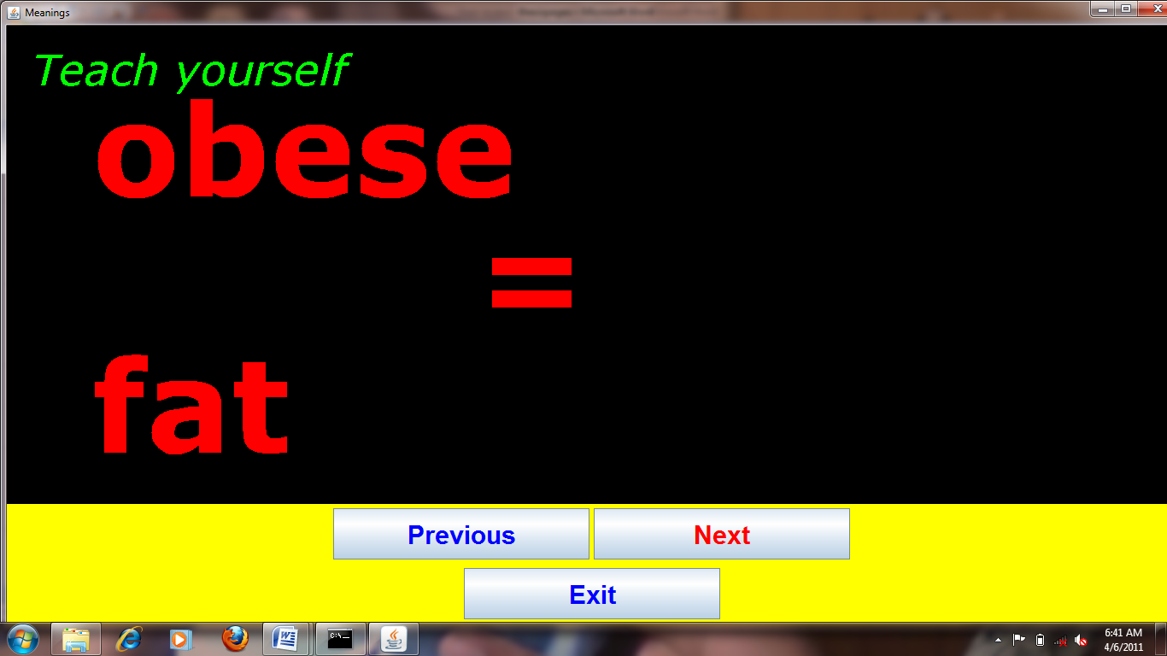

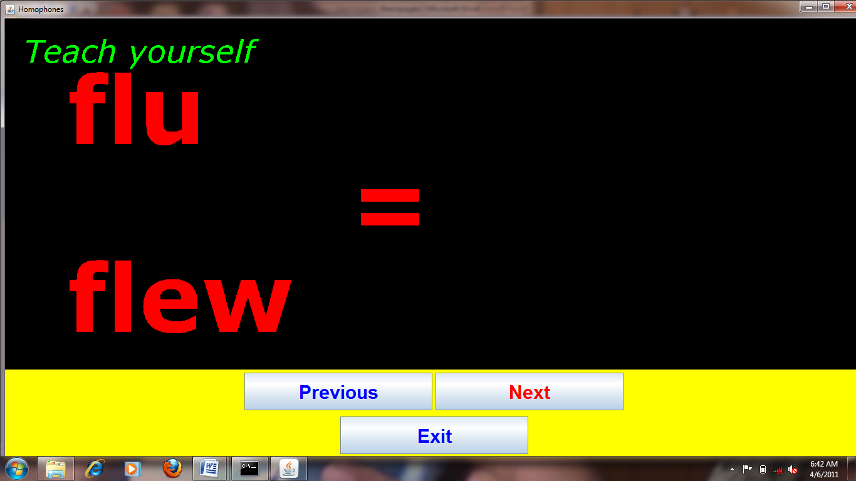

This figure demonstrates the screen shots for the teach yourself mode in English. They can learn meaning, opposites, homophones, vocabulary on their own.

**Screen shot for puzzle generation in English**

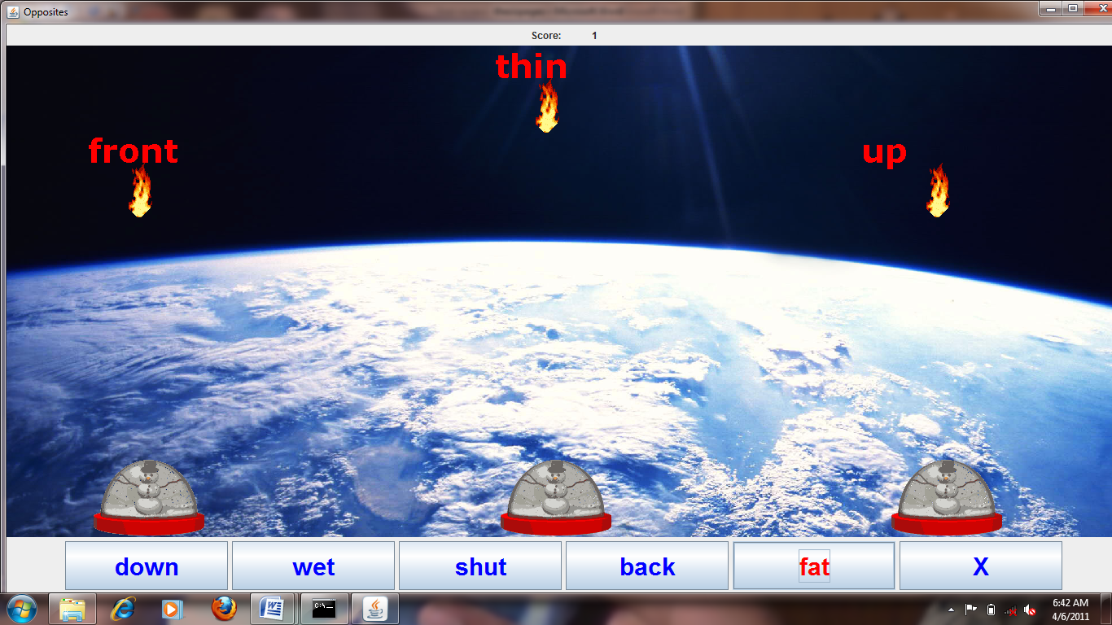

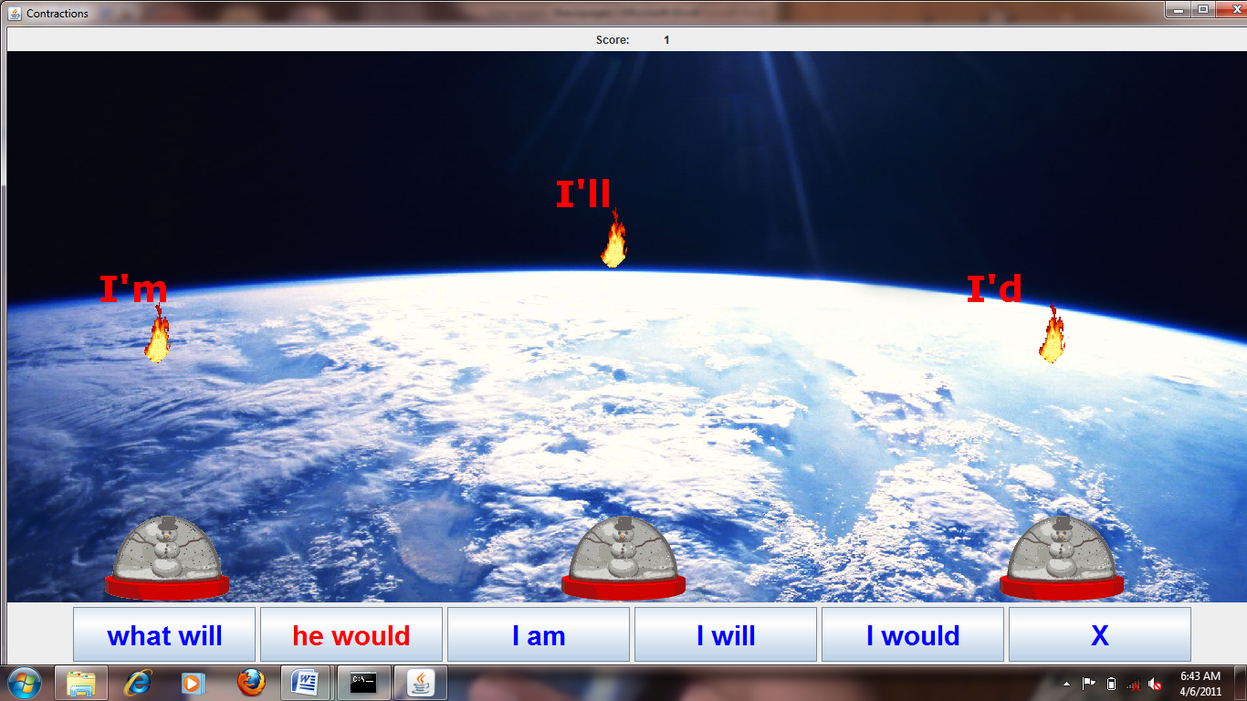

This figure demonstrates the self train mode in English. In this mode the player can learn by answering the puzzles which are generated based on what they have learnt.If they click correct answer for the puzzle generated new puzzle is generated else the igloo is destroyed.

**CONCLUSION**

Mind trainer can be used as an effective tool by anyone to learn and test themselves in basic English and maths. The environment provided by mind trainer is a type of gaming environment which motivate children to learn more. The scanning mode provided enable the children to handle everything themselves. Thus the dependence of differently abled children on others is greatly reduced.

.